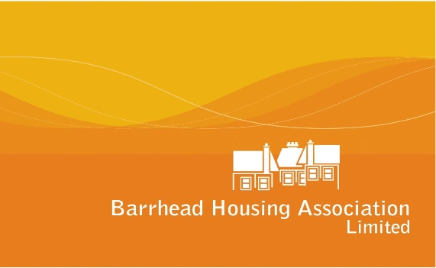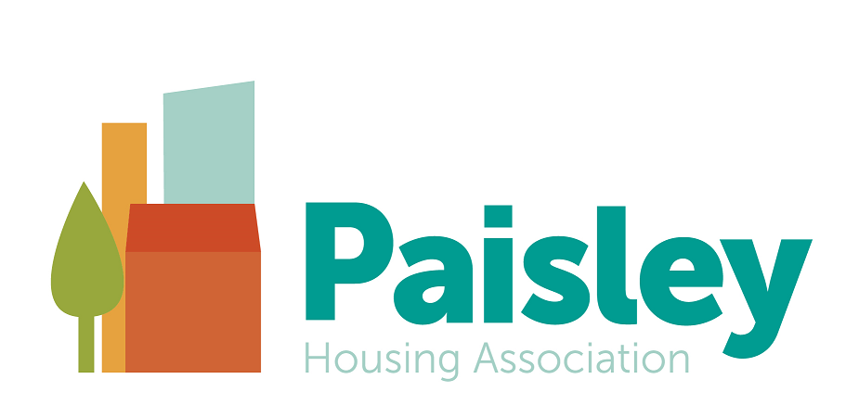

FLAIR (the Federation of Local Associations in Renfrewshire and East Renfrewshire), is a partnership of local housing associations operating in Renfrewshire and East Renfrewshire. FLAIR has been working together for many years and organisations participating are Barrhead HA, Bridgewater HA, Ferguslie Park HA, Linstone HA, Paisley HA and Williamsburgh HA. Our mutual aim is to collaborate on a range of areas to help and support our local communities.

**Temporary Digital Engagement Assistant 12 months Fixed Term Contract**

**Employers In Voluntary Housing, Grade 6, PA17-20 £28,538- £31,198**

Two FLAIR organisations being Barrhead HA and Paisley HA are both seeking to recruit a Digital Engagement Assistant on a part-time basis of 17.5 hours per week on a 12 month fixed term basis.  The post holder will assist in the promotion and delivery of meaningful digital participation actives to meet the needs and aspirations of our customers to increase digital skills, promote connectivity and support the use of digital platforms and social media as a tool for communication and engagement.

The job descriptions for the post are broadly similar and the person spec for this post is the same.

As a result of our collaborative approach we are providing an excellent opportunity to recruit either 1 candidate on a full time basis across both organisations @ 17.5 hours or 2 candidates to be recruited to individual organisations.  The full time post-holder would still have 2 contracts for respective associations.

Please complete the application form and ensure you select whether you wish to be considered for the post at Barrhead Housing and/or Paisley Housing at 17.5 hours or if you want to be considered for both Housing Associations at 35 hrs.  Joint interviews will be held with respective organisations for all successful applicants to ensure consistency of selection.

Barrhead Housing Association & Paisley Housing Association is a Disability Confident Employer and offers an interview to disabled people who meet the minimum criteria for the job.

**Closing date for applications is 12 noon 28 September 2020, and interviews will take place week 7 October 2020. Further detail will follow to shortlisted candidates regarding the format of interview, which are likely to be conducted via Zoom.**

**Excellent terms and conditions of employment apply. Barrhead Housing & Paisley Housing Association is accredited as a Living Wage Employer & aims to be an equal opportunity employer.**

Our recruitment package is available from our websites

<https://www.barrheadha.org/about-barrhead-housing-association/staff-vacancies/>

<https://paisleyha.org.uk/staff-recruitment/>

Further information and return of applications can be obtained from:

Iain MacLean ([enquiries@barrheadha.org](mailto:enquiries@barrheadha.org))

Barrhead Housing Association Ltd.

Telephone: 0141 881 0638

[www.barrheadha.org](http://www.barrheadha.org)

__________________________________________________________________________________

**Barrhead Housing Association Limited is a recognised Scottish Charity - No. SC 036265**

***‘At the heart of our community – investing in your future’***



***Working for over 30 years in the community***

**__________________________________________________________________________________**

**Paisley Housing Association,** 64 Espedair St, Paisley, PA2 6RW

Scottish Charity No SC035589

**Paisley South Property Services Ltd** (subsidiary of PHA)

Registered in Scotland No.SC264883

Property Factor Registration Number PF000305

