BARRHEAD HOUSING ASSOCIATION

SHELTERED HOUSING MAIN STREET

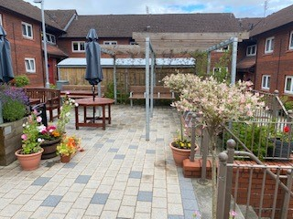
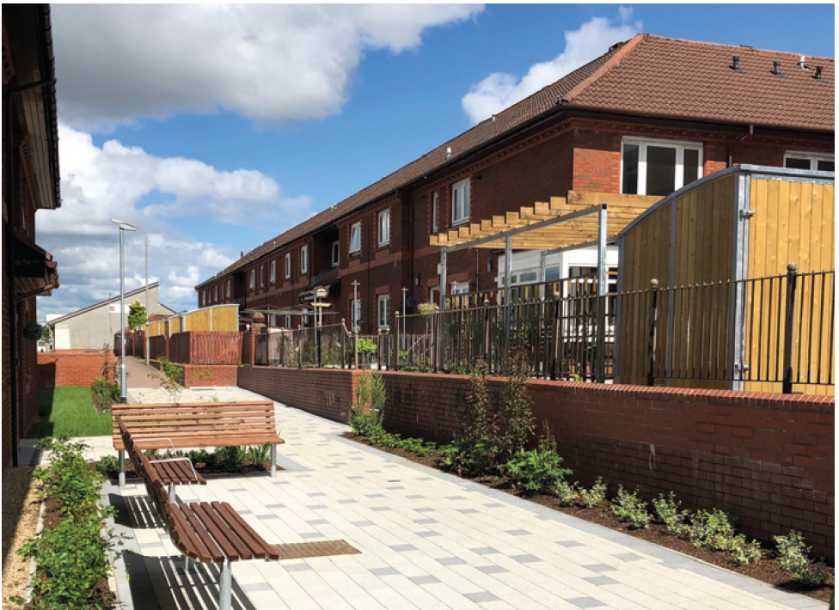

Welcome to your new home
Welcome to your new home. This handbook explains what sheltered housing is, what facilities our complex normally have and the services our Housing Support Assistant provide.
We have split the handbook into easy-to-read sections and it covers all areas of our service. We produced it with the help of tenants already living in our sheltered-housing accommodation so we hope that you find it useful and that it helps you to understand our services.
If you need any more information, our Housing Support Assistant and Customer Services Officer will be pleased to help you.

What is sheltered housing?
Sheltered housing aims to provide convenient, well-planned and self-contained houses for elderly people, offering them the opportunity to retain the maximum possible independence while giving a sense of security, companionship with the background support of a Housing Support Assistant and speedy help in an emergency.
The complex consists of 28 self-contained and independent properties ranging in size from 1 bedroom to 2 bedrooms flats.

The sheltered-housing support assistant is the member of staff you are most likely to see on a day-to-day basis. However, you may also have regular contact with your Customer Services Officer.

The role of the Housing Support Assistant.
When you move in – they will welcome you and show you around the shared areas.
They will explain the alarm system and other facilities, and tell you about local services and social activities.

Once you are a tenant – they will contact you every day to make sure you are alright. If you do not want a daily call we will ask you to confirm this by signing a ‘no contact’ form.
Once you do this, we will keep your personal details up to date and will help you to contact other agencies to make sure that you get the support you need.
There is also a motion sensor in the hallway of each flat and a report goes through daily to either the Housing Assistant or Safety Net depending who is covering the system on a particular day. It is therefore important you inform us if you intend on being away from the property overnight

If have an emergency – they will respond, and make sure further help is provided if you need it.
If you are lonely – they will help you stay in contact with your relatives, and with the Community Health and Care Partnership, health and other organisations which can help you.
If you want to talk – they are there and will always respect your privacy and your right to confidentiality. If you want a long talk about something, they will probably arrange a special time for that, so that calls to other tenants are not delayed.
If you have problems with your home – they can provide you with the contact details of the repairs and maintenance service if you have a problem such as a leaking pipe or broken light switch so that you can report it, or they can report it for you.
If you have to fill in forms – they will be happy to help you fill in forms about housing or benefits.

Shared areas (this includes shared areas such as the lounge & toilets - they are responsible for cleaning the shared areas, and they appreciate your help in keeping these areas clean and tidy.
Security – they look after security at each complex and ask that you help with this too.
Tenants’ activities – they help organise activities and social events for tenants. They will involve you in discussions about activities and events they would like to take place.

Keys – we will make specific arrangements with each tenant on what action is to be taken in an emergency. This could include holding a spare key, but the tenant must know that they have the right to make other arrangements.

Things we can’t do
The Housing Support Assistant cannot carry out nursing, shopping or cleaning for you, or picking up your medication, but if you need this type of help they can arrange contact with services or family members who can help you.
We are not allowed to handle your money and cannot accept money from you for safekeeping or for any other reason.
Despite all the support we give you, we cannot take the place of your family and friends. We hope you will maintain contact with your family and friends and that they will continue to give you as much care and support as they did before you moved into your new home.

Charges for the service

There are various services available to tenants within the Sheltered Complex such as welfare checks, emergency call system, ground maintenance, communal facilities etc. A breakdown of these charges can be provided on request. We are currently undertaking a full review of our rent and service charges and full details of charges will be updated on this document once this has been completed.
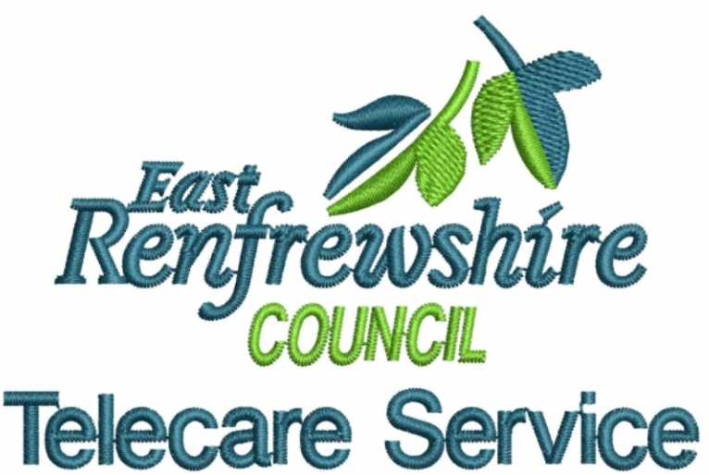

Telecare is also known as a community alarm. It provides a link from our tenant’s home to their 24 response centre, Safety Net. Equipment to facilitate this is contained within our sheltered housing office for switchover to staff.

The alarm allows you to call for help in an emergency at the touch of a button.

How Telecare works

The alarm unit is fitted to a telephone point and mains power supply. Any sensors are linked by tiny radio transmitters so there are no visible wires.

The equipment raises an alert to Safety Net. The Safety Net operators have access to the tenant’s details and communicate with them directly through the alarm unit.

Safety Net operators are trained to deal with emergency situations. They can contact:

a member of your family your doctor or nurse emergency services such as ambulance or police a mobile response carer to visit your home.

Telecare benefits

Telecare doesn't replace your family or carers who visit you at home. However, it can give you confidence to live at home safe in the knowledge help is at hand when you need it.

If you are a carer, Telecare can provide reassurance the person you care for can get help when you're not available.

As part of our Sheltered Housing Tenancy Agreement – all tenants are required to sign-up to the basic telecare – carried out by Safety Net from East Renfrewshire Council.

Some tenants are signed-up to the enhanced service – this cover responders physically going out if someone falls etc – rather than contacting the family & getting them to go out.

Services range from providing reassurance over the phone, personal care and support for unpaid carers to responding to falls and arranging the attendance of emergency services.

Such services often involve unplanned attendance in people’s homes, with little advanced information as to the situation being entered into.

The Telecare/Community Alarm Service has an Alarm Receiving Centre based in East Renfrewshire where alerts are received and initially managed by call handlers.

Monday to Friday – the telecare system is switched over the Sheltered Housing Support Assistant when not on site – and at times of planned and unplanned absences it remains with Safety net – where we have a contract in place to cover these eventualities.

Until further notice the system is manned by Telecare 24/7 until our Housing Support assistant is back on site permanently.

When is help available?
There will be someone on call to provide help 24 hours a day, seven days a week.

Help is provided by either our staff or via the Telecare System.
In emergencies we also have the back-up support of the whole of the Barrhead Staffing team.
Sheltered housing is designed for people who can live independently with support. If you find you need more support than you get in your sheltered housing, you should talk to the Housing Support Assistant about it. They can discuss other possibilities with you and help you make contact with the appropriate organisations.

How to get help in an emergency
We have an emergency-help system that gives you peace of mind because you know that you can easily call for help if you need it.
The alarm call system is directly connected to the Housing Support Assistant office. If they are not available, your call will be connected to the Safety net control centre. This means that you can call for help at any time if you are suddenly taken ill, have an accident or are faced with a problem. Staff at the control centre are always on hand to speak to you and will arrange any help you need. Even if you cannot speak, the staff will know who is calling as each alarm has its own special call number.
Our Staff will explain the emergency system to you when you move in, and will show you how to use it. Remember, there is always someone available to help you in an emergency, or if you have a problem, 24 hours a day, every day.

Your personal information and tenant support plans
Within your first few weeks in your new home, the Housing Support Assistant will fill in a tenant support plan with you. The support plan helps us to identify the support you need to help you live independently and in safety and comfort.
We will help you and your relatives or other people who support you to co-ordinate existing services and identify other services you may need. The Housing Support Assistant will review your support plan every six months, or sooner if needed.
If you would like a review sooner, just ask us.
As well as your support plan, we will carry out a risk assessment with you. The assessment balances any risks you may face with promoting your independence.
We may ask you for information that we or the control centre might need in an emergency, such as how to get hold of your next-of-kin and your doctor.
You will be asked to complete a form with these details.
It’s also important to tell us the Housing Support Assistant your about any special health problems you have, such as diabetes or an allergy to certain antibiotics or medication.
Your right to confidentiality is very important to us. We will hold your personal information securely and will not give it to anyone else without good reason.

Regulating your Housing Support Service
Our sheltered housing service is registered with the Care Inspectorate as a Housing Support Provider. Housing support is help that enables someone to manage on a day-to-day basis while they are living in their own home. The Care Inspectorate regulate our services and we must be able to prove that the service meets various national standards.
Tenants receiving this service will have an individual support plan which will be reviewed on a regular basis:
Your tenancy
A summary of your rights and responsibilities as a Scottish secure tenant is set out below. If you are a joint tenant with another person, you both have equal rights and responsibilities.
You have a Scottish secure tenancy. Full details of your rights and responsibilities are set out in your tenancy agreement, which is a legal contract between you and us. If you want to discuss any part of your agreement in more detail, please contact your Customer Services Officer.

Your rights as a Scottish secure tenant
Security of tenure:
As a Scottish secure tenant, you have security of tenure. This means that you have the right to stay in your home for as long as you want. You cannot be evicted from your home unless you break the terms of your tenancy agreement, in which case we will need a court order to evict you.
The right to a joint tenancy:
Anyone who lives with you (or intends to live with you) can apply for a joint tenancy. We will agree to this unless we have a good reason not to. This will include ensuring the joint tenant is also eligible to live in sheltered housing.

Anyone applying for a joint tenancy must also meet our conditions for sheltered housing.
The right to take over a tenancy:
If you die, other members of your household may be able to take over the tenancy. This is known as succession. Your husband, wife, live-in partner (including same-sex partner), joint tenant or other person living with you can only apply to take over your tenancy by succession if they meet our conditions for sheltered housing.
Your right to apply for a mutual exchange or transfer:
A mutual exchange is when you swap your home with another council tenant or housing association tenant. A transfer is when you move to another council property that you are offered from our waiting list.
You must meet certain conditions before we can consider you for either a mutual exchange or a transfer. For example, your rent payments will usually have to be up to date. We will not refuse to give you permission unless we have a good reason. If we do refuse, you can appeal to the sheriff court.
If you apply for a mutual exchange within a sheltered-housing complex you must make sure the person you are asking to exchange with meets our conditions for sheltered housing.

Your right to compensation for improving your home:
If you have made certain types of improvements to your home with our permission, you can claim compensation when you end your tenancy, when you give your tenancy to someone else, or if you exchange or transfer or tyour tenancy. You must contact us before you carry out any work.

You’re right to repair:
The right to repair scheme allows you to have certain repairs carried out by an approved contractor, if we don’t carry them out within a certain time frame. There are full details of the right to repair scheme in the leaflet ‘The Right to Repair Scheme’, which we gave you with your tenancy agreement. Remember, you must contact us before you carry out any work.

You’re right to buy your home:
You do not have the right to buy your home because it is a sheltered-housing property and the law also changed which stopped this right to all tenants in Scotland.

Ending your tenancy
Your tenancy can come to an end in any of the following ways.
- You give us 28 days’ notice in writing
- You and we agree, in writing, to end the tenancy
- We get a court order to evict you
- You move out of your home without telling us
- You die and nobody takes over the tenancy
- Your tenancy is converted to a short Scottish secure tenancy

Your sheltered-housing complex

The spare key

We keep a spare key in a secure location within our Housing Support Assistant offices. This spare key to your home is in case they need to get into your home in an emergency (for example, if you have had a fall and cannot get to the door to open it). It is a good idea for a friend or relative who lives nearby to also hold a spare key (and for the sheltered-housing supervisors to know about this). You need to get our permission before fitting new locks to the door.
Security – Once the Common Room Works are Completed.
The complex can be used at any time as long as the lock up procedures are followed. Family and friends are welcome to join in at the complex but must be accompanied by the tenant themselves or an adult if they are under 16. Visitors must ensure that the facilities are left how they have been found.
Tenants are free to use the facilities at any time and also the laundry. Please ensure all doors are locked and lights are put off before you exit.
Access to the lounge is by the key fob for your individual close.

Going away?
Tell us when you are going away for a while, especially if you will be away overnight, so they do not think you have disappeared unexpectedly. You do not want them to spend time looking for you if there is a fire alarm or the building has to be evacuated.
They may also need to come into your home if there is an emergency (for example, a burst pipe).

Visitors & Respect for Others
You are responsible for your visitors’ actions while they are in or around your home. If they cause nuisance or harass anyone in your neighbourhood, we may hold you responsible.

Your Tenancy Agreement States:
- You, those living with you, and your visitors, must not harass or act in an anti-social manner to, or pursue a course of anti-social conduct against, any person in the neighbourhood. Such people include residents, visitors, our employees, agents and contractors and those in your house.

- Anti-social means causing or likely to cause alarm, distress, nuisance or annoyance to any person or causing damage to anyone's property. Harassment of a person includes causing the person alarm or distress. Conduct includes speech. A course of conduct must involve conduct on at least two occasions.

- In particular, you, those living with you, and your visitors must not:

• make excessive noise. This includes, but is not limited to, the use of televisions,
hi-fi's, radios and musical instruments and DIY tools;
• fail to control your pets properly or allow them to foul or cause damage to
other people's property;
• allow visitors to your house to be noisy or disruptive;

- In addition, you, or those living with you and your visitors must not behave in an abusive or violent manner towards any of our employees, agents or contractors or neighbours who have contact with you, those living with you and your visitors concerning any matter arising from your occupancy of the house in terms of this agreement;

You will be in breach of this Agreement if you, those living with you, or your visitors do anything which is prohibited in within the Terms of your Tenancy Agreement.

Lodgers
They are not allowed in sheltered housing accommodation under any circumstances as the accommodation is specially built for the elderly.

Carers
We understand that you may sometimes feel unwell and may require a carer/family member to stay over. It’s important that you let us know about this, especially for Fire Safety information and for Safety net.

Unfortunately we cannot allow a carer to stay regularly or on a more permanent basis, as we need to think about the purpose of sheltered housing and the impact this may have on your neighbours.

Noise
We understand that daily activities create some level of noise, but there are some types of noise that are unacceptable, and there are certain times of the day and night when noise may cause a nuisance. We expect all tenants to consider their neighbours. If your neighbours complain, please take their comments seriously and try to solve the problem with them.

Pets
Unfortunately you cannot keep dogs and cats in schemes.
Mobility Scooters
Mobility scooters are not allowed within communal areas due to fire safety regulations. With that in mind we have provided a number of individual housing units within the communal backcourt area. These will provide charging units and we will also provide you with a key to ensure your property is kept safe.

Neighbour disputes and antisocial behaviour
Your neighbours may not realise that they are causing a problem. A friendly word with them may be enough to sort out the problem. If you can, try to solve the problem between yourselves. More often than not, disputes between neighbours can be avoided simply by talking to each other. If you feel that you can’t deal with the situation on your own, contact your local Customer Services Officer who will investigate your complaint and keep you informed of any action they have taken.

Using your home for illegal purposes
You must not use your home for illegal purposes. If you or a member of your household is convicted of an offence, you will have broken your tenancy agreement and we can ask the sheriff for permission to evict you.

Harassment
Harassment is any behaviour or threatened behaviour that alarms or distresses another person. It includes discrimination against someone because of their race, colour, nationality, sex, sexuality, disability, age, religion or other reason. If we find that you, or anyone who lives with you or visits you, are causing harassment, we can ask the sheriff for permission to evict you.

Using shared areas
If your home shares areas (such as stairs and bin areas) with other homes, please respect other people’s privacy and keep the areas you share clean and tidy. Your close and communal areas within the building are covered by cleaning services.

Cleansing/Bins

The complex now has various days that the bins are emptied by East Renfrewshire council for household, recycling and plastic/paper etc. The bin sheds do not need to be left open for this as the cleansing workers have keys. All responsibility for rubbish uplift is the councils and not BHA. If you have a missed uplift or issue with you bins etc. please contact the Cleansing Department direct on – 0141 577 3001
Once a month the cleaning company with sweep out the bin sheds and mop them out.
Each tenant will have their own key to the bin shed which should always be kept locked. Each tenant has their own black household bin and is responsible for putting their bag in and not overflowing the bin. There is also a key box at the bin store and the number is 4622.
All tenants in the close share the other recycle bins. We ask that you wash out any plastics such as milk cartons so the bin sheds do not smell.
The bin men will only lift household rubbish that is in the black bin and recycle items. They will not lift any other items such as cardboard boxes or anything that is not in the bin.
No other items should be stored in the bin shed but disposed of either at the local dump or by an uplift from the council.

Running a business from home
If you, or anyone living with you, want to run a business from your home, you must get our permission in writing first.

Smoking in shared areas
It is against the law to smoke in indoor shared areas in your complex. This includes corridors, stairwells, lifts, shared lounges, our office, and shared bathrooms. We would prefer it if you didn’t smoke when staff are visiting you in your home.

Common room lounge
The common room lounge has a small kitchen attached. This is the centre of the social life at your complex, once life returns after the works are completed at the Common Room.

Talk to us to find out what takes place there. Sometimes our staff may need to use the common room for meetings or training, and sometimes we allow other people to use it too– but tenants’ planned activities take priority.
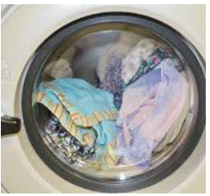

Shared laundry room
The complex offers washing and drying facilities. Tenants will be allocated a slot to carry out their laundry if they require to use these facilities from Monday to Friday between the hours of 8am to 5pm. Otherwise tenants can use the laundry at a time convenient to them whilst not interfering with other tenants allotted time slots. This is covered within your service charge.

Gardens and grounds
The gardens and grounds at your complex are managed by our landscape contractor. If you would like to help maintain the gardens and grounds, this is normally possible and welcomed (even if you just want to potter about in the garden) then speak to us.

Communication (post Covid)
All tenants will be given, in advance, information regarding events, meetings etc. by the HSA each month so that you can attend any important events or activities of interest.
There will be regular tenants meetings every 2 months for tenant updates and feedback. Notices are on the close notice boards of exact dates for the coming year. We are currently trying to establish an online way for us all to catch up in the short-term and this is currently being developed.
We will also inform you if and when the Housing Support Assistant is going off on holiday and enquire about what service you would like from Safety net in their absence. If the absence is due to sickness Safety Net will still provide a welfare check once they have been notified of the absence so this may be a little later than the usual call but they will be in touch only if you require these calls on a regular basis.
If for any reason you have not been given a call you can use the call system to let them know you are ok if you needed to go out.

HOW DO I MAKE A COMPLAINT?
We value complaints and use information from them to
help us improve our services.
If something goes wrong or you are dissatisfied with our services, please tell us. We can provide you with a full leaflet which describes our complaints procedure and how to make a complaint. Its also available via our website https://barrheadha.org/search/complaints/
It also tells you about how we will handle your complaint and what you can expect from us.

What is a complaint?

We regard a complaint as any expression of dissatisfaction about our action or lack of action, or about the standard of service provided by us or on our behalf.

What can I complain about?
You can complain about things like:
- failure or refusal to provide a service
- inadequate quality or standard of service, or an unreasonable delay in providing a service
- delays in responding to enquiries or requests
- unfairness, bias or prejudice in service delivery
- lack of provision, or the provision of misleading, unsuitable or incorrect advice or information
- a repair that has not been carried out properly or in an agreed timeframe
- dissatisfaction with one of our policies or its impact on the individual
- failure to properly apply law, procedure or guidance when delivering services
- failure to follow the appropriate administrative process
- conduct, treatment by or attitude of a member of staff or contractor (except where there are arrangements in place for the contractor to handle the complaint themselves); or
- disagreement with a decision, (except where there is a statutory procedure for challenging that decision, or an established appeals process followed throughout the sector).

Your complaint may involve more than one Barrhead Housing Group service, or be about
someone working on our behalf.

What can’t I complain about?
There are some things we can’t deal with through our complaints handling procedure. These include:
  - a routine first-time request for a service
  - a request for compensation only
  - issues that are in court or have already been heard by a court or a tribunal (if you decide to take legal action, you should let us know as the complaint cannot then be considered under this process)
  - disagreement with a decision where there is a statutory procedure for challenging that decision (such as for freedom of information and subject access requests), or an established appeals process followed throughout the sector
  - a request for information under the Data Protection or Freedom of Information (Scotland) Acts
  - a grievance by a staff member or a grievance relating to employment or staff recruitment
  - a concern raised internally by a member of staff (which was not about a service they received, such as a whistleblowing concern)
  - a concern about a child or an adult’s safety
  - an attempt to reopen a previously concluded complaint or to have a complaint reconsidered where we have already given our final decision
  - abuse or unsubstantiated allegations about our organisation or staff where such actions would be covered by other policies
  - a concern about the actions or service of a different organisation, where we have no involvement in the issue (except where the other organisation is delivering services on our behalf).

What if I’m still dissatisfied?
After we have given you our final decision, if you are still dissatisfied with our decision or the way we dealt with your complaint, you can ask the Scottish Public Services Ombudsman (SPSO) to look at it.

The SPSO are an independent organisation that investigates complaints. They are not an advocacy or support service (but there are other organisations who can help you with advocacy or support).
You can ask the SPSO to look at your complaint if:
- you have gone all the way through Barrhead Housing Group’s complaints handling procedure
- it is less than 12 months after you became aware of the matter you want to complain about; and
- the matter has not been (and is not being) considered in court.

The SPSO will ask you to complete a complaint form and provide a copy of our final response to your complaint. You can do this online at www.spso.org.uk/complain/form or call them on Freephone 0800 377 7330.
You may wish to get independent support or advocacy to help you progress your complaint. See the section on Getting help to make your complaint below.
The SPSO’s contact details are:
SPSO
Bridgeside House
99 McDonald Road
Edinburgh
EH7 4NS
(if you would like to visit in person, you must make an appointment first)

Their freepost address is:
FREEPOST SPSO

Freephone: 0800 377 7330
Online contact www.spso.org.uk/contact-us
Website: www.spso.org.uk

Complaints About Our Housing Support Service
If your complaint relates to a care service we provide, you can choose whether to complain to us or the Care Inspectorate. You can find out more about their complaints procedure, or make a complaint, by contacting them.
The Care Inspectorate has several offices around Scotland. Please refer to: http://www.scswis.com/

