Home Energy Scotland
Newsletter and social media content (tenants) February 2022

Worried about your energy bills? Home Energy Scotland can help
On Thursday 3 February, Ofgem announced an increase to the energy price cap meaning that many Scottish households will see increases in energy bills from 1 April 2022.
The increases are driven by a record rise in global gas prices over the last six months, with wholesale prices quadrupling in the last year alone. While you might find this news worrying, we want to assure you that help is available.
Home Energy Scotland is an energy advice service funded by the Scottish Government helps people in Scotland create warmer homes, reduce their energy bills, and lower their carbon footprint. The service has no affiliation with energy suppliers and the team never cold call.
The Home Energy Scotland advice team can:

- Provide practical tips and impartial advice for reducing the amount of energy you use at home to keep your bills low

- Check if you’re eligible for funding or discounts from energy suppliers such as the Warm Home Discount Scheme under which you could get £140 off your electricity bill for next winter

- Help you get a benefits and tax credit check so you’re not missing out on additional income

Get in touch today

If you are or someone you know is worried about energy bills, call freephone 0808 808 2282, send us an email adviceteam@sc.homeenergyscotland.org, or request a call-back via our website at homeenergyscotland.org. Lines are open Monday to Friday 8am to 8pm and Saturday from 9am to 5pm.

Facebook

Has the recent news about rising energy bills caused concern? Unsure what you can do to keep bills down? Some small changes can make a world of difference and @HomeEnergyScotlandSC can help. Find out more at https://bit.ly/home-energy-help

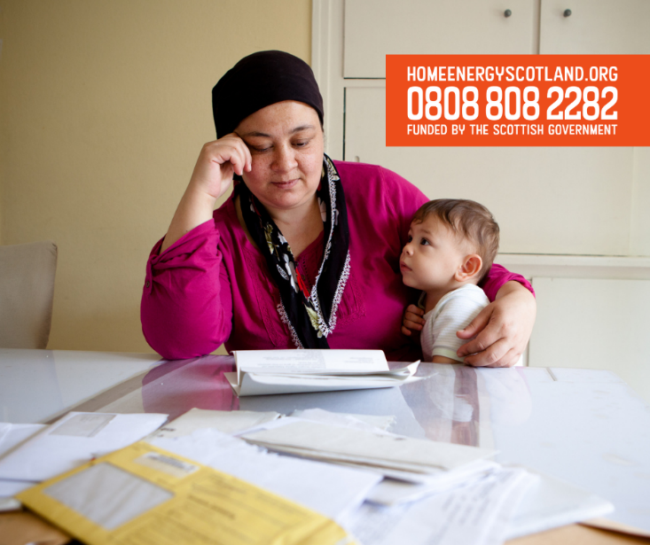

Twitter

Has the recent news about rising #EnergyBills caused concern? Unsure what you can do to keep bills down? Some small changes can make a world of difference. Here's some simple advice from @HomeEnergyScot https://bit.ly/home-energy-help

